Explainable Credit Risk Prediction Using Machine Learning with Historical Cohort Analysis and Fair-Lending Audit
Jagu Madhura  Dept. of Computer Science and Engineering  Koneru Lakshmaiah Education Foundation  Hyderabad, India  2420030535@klh.edu.in | Rapuru Lokesh Reddy  Dept. of Computer Science and Engineering  Koneru Lakshmaiah Education Foundation  Hyderabad, India  2420030534@klh.edu.in | Chintlapati Mani Srikar  Dept. of Computer Science and Engineering  Koneru Lakshmaiah Education Foundation  Hyderabad, India  2420030610@klh.edu.in | Dr. N. Sunanda  Dept. of Computer Science and Engineering  Koneru Lakshmaiah Education Foundation  Hyderabad, India  Associate Professor

Abstract—Credit risk assessment is central to lending, yet manual and rule-based evaluation is slow and may miss nonlinear patterns, while opaque models are hard to defend in a regulated setting. This paper presents an explainable credit risk prediction system built on the Statlog German Credit dataset (1,000 applicants, 30% defaults). After a leakage-free preprocessing pipeline producing 61 features, logistic regression, decision tree, random forest and a calibrated support vector machine are trained with balanced class weights and compared on a 200-applicant hold-out set and by five-fold cross-validation. Random forest is selected for its ROC-AUC of 0.797, default recall of 71.7% and exact SHAP explainability; the support vector machine attains the highest accuracy (78.0%) but detects only 48.3% of defaulters. Predicted default probability is mapped to Low (<28%), Medium (28–58%) and High (≥58%) risk tiers, whose observed default rates on unseen data are 8.5%, 24.8% and 59.6%, confirming that the tiers are well ordered. The system adds SHAP and LIME explanations, a nearest-neighbour cohort of similar borrowers, a what-if simulator and a four-fifths-rule fairness audit, delivered as a Streamlit application. The audit reveals lower approval for applicants under 25 (disparate impact 0.635), illustrating why the tool is positioned as decision support under human review.
Keywords—credit risk prediction, machine learning, random forest, explainable AI, SHAP, LIME, fairness, cost-sensitive learning, loan default
I. INTRODUCTION
Lending is among the oldest and most important services of banks and financial institutions, and its profitability rests on one question: will the applicant repay? A wrong answer in either direction is costly. Approving a borrower who later defaults creates a direct financial loss, while rejecting a creditworthy borrower loses revenue and customers. Traditional credit scoring based on manual verification and fixed decision rules becomes difficult to maintain as the number of applications and the volume of historical information grow [1]. Rule-based checks also struggle to represent interactions between applicant attributes, such as the combined effect of a long loan term, a large amount and a weak savings position.
Machine learning offers a way to learn classification patterns from past loans and to apply them consistently to new applicants. Large benchmarking studies have shown that modern classifiers are competitive for credit scoring [5], and applications to consumer credit data show that they can capture nonlinear relationships that linear scorecards miss [6]. However, in lending, predictive accuracy alone is not enough. First, errors are asymmetric: a missed defaulter is considerably more expensive than a good applicant who is sent for additional review [12]. Second, lending decisions affect people and are regulated, so predictions must be explainable to analysts and, ultimately, to applicants [16]. Third, models trained on historical data may inherit unequal treatment of demographic groups and must be audited [15].
This paper therefore treats credit risk prediction as a complete decision-support problem rather than as a single classification task. We build and evaluate a system on the public Statlog German Credit dataset [10] that (i) compares four classifiers under a leakage-free protocol with recall-sensitive metrics, (ii) converts predicted probabilities into three actionable risk tiers and checks that the tiers are meaningful on unseen data, (iii) explains each prediction through SHAP, LIME, similar historical borrowers and a what-if simulator, and (iv) audits approval rates for fairness using the four-fifths rule. The system is packaged as a Streamlit web application with an automated test suite.
The main contributions are: (1) a reproducible, leakage-free preprocessing and training pipeline that yields 61 model inputs from 20 raw attributes; (2) a comparison of logistic regression, decision tree, random forest and calibrated SVM using a hold-out set, five-fold cross-validation, ROC analysis, confusion matrices and a threshold analysis; (3) a three-tier risk classification whose thresholds are anchored to the base default rate and the cost asymmetry and validated by observed tier default rates; (4) an explainability layer combining exact tree SHAP values, LIME verification, nearest-neighbour cohorts and counterfactual what-if simulation; and (5) a fair-lending audit that exposes a disparity for younger applicants. The rest of the paper is organised as follows. Section II reviews related work, Section III describes the data, Section IV the methodology, Section V the system, Section VI the experimental setup, Section VII the results, Section VIII covers ethical and regulatory considerations, Section IX limitations and future work, and Section X concludes.
II. RELATED WORK
In credit risk management the central quantity is the probability of default (PD), that is, the probability that a borrower fails to meet the repayment obligations within a given horizon. Together with the loss given default and the exposure at default, it determines the expected loss on a loan, and lenders use PD estimates for approval, pricing and provisioning decisions. This paper focuses on the application-scoring problem: estimating PD at the time of application from the information in the application form. Regulators and standard-setters expect such models to be validated, documented and monitored, and laws in many jurisdictions require lenders to give applicants meaningful reasons for adverse decisions and restrict decisions that are based solely on automated processing. These requirements explain the growing interest in explainable and auditable scoring systems.
Hand and Henley reviewed statistical classification methods for consumer credit scoring and discussed issues specific to the domain, such as the classification of applicants into risk classes and the use of limited, historically biased samples [1]. Logistic regression has long been the industry standard because it is simple, well understood and interpretable through its coefficients [2]. Tree-based methods represent nonlinear decision boundaries through sequences of feature tests, and random forests combine many randomised trees to reduce variance and improve robustness [3], [17]. Support vector machines construct a maximum-margin decision surface in a transformed feature space and are effective when a simple linear boundary is insufficient [4].
Lessmann et al. benchmarked a wide range of classifiers across several credit datasets and found that ensemble and other advanced methods can outperform traditional logistic regression, although differences between datasets and institutions are large [5]. Khandani et al. applied machine learning to consumer credit-risk forecasting and showed that nonlinear models capture patterns in consumer data that conventional models do not [6]. These studies motivate our comparison of several model families rather than the assumption that one algorithm is always superior.
Default is a minority outcome, and standard accuracy can look high even when most defaulters are missed. Two families of remedies are common: resampling, such as SMOTE, which synthesises minority examples [14], and cost-sensitive learning, which assigns a larger penalty to costly errors [12]. We use class weighting, a cost-sensitive approach that does not alter the data distribution and therefore keeps the hold-out set realistic. We also report recall and ROC-AUC [13] in addition to accuracy.
Black-box models need explanations before they can be trusted in lending. Guidotti et al. surveyed methods for explaining black-box models and distinguished global from local explanations [16]. SHAP assigns each feature an additive contribution derived from Shapley values and has an exact, efficient algorithm for tree ensembles [7]. LIME fits a simple surrogate model around a single prediction using local perturbations [8]. Because the two methods rest on different principles, we use LIME as an independent check on SHAP.
Fairness criteria for classifiers include demographic parity and equality of opportunity [15]. In lending, the four-fifths (80%) rule compares the approval rate of a protected group with that of a reference group and is widely used as a screening test for adverse impact. We adopt this rule because it is simple enough to be applied in an analyst dashboard. The present work combines the strands above in one auditable, tested application.
Most studies of credit scoring concentrate on one question, which classifier ranks applicants best. Our emphasis differs: we ask what a lender needs in order to use a model responsibly. Accordingly, besides comparing classifiers, we assess probability calibration, validate the risk tiers against observed outcomes, quantify statistical uncertainty, study the cost-based choice of threshold, and examine fairness through both approval rates and error rates. The explainability layer is treated as part of the system, with SHAP and LIME for attribution, nearest-neighbour cohorts for case-based evidence and counterfactual simulation for actionable guidance. This combination of prediction, explanation and audit in a single tested application is the main practical contribution of the paper.
Table A summarises how the proposed system differs, in capability, from two common alternatives.
TABLE A. CAPABILITY COMPARISON
Capability | Manual scorecard | Black-box ML | Proposed
Learns nonlinear patterns | No | Yes | Yes
Multi-model comparison | No | Rare | Yes
Per-case explanation | Partly | No | SHAP + LIME
Similar-case evidence | No | No | KNN cohort
Counterfactual what-if | No | No | Yes
Fairness audit | Rare | Rare | Four-fifths rule
Audit log | Manual | Rare | Automatic

III. METHODOLOGY
A. System overview
Fig. 6 shows the architecture. Data from the credit file and the applicant form pass through the preprocessing layer into the modelling layer, where the four classifiers are trained and evaluated. The selected model feeds an explainable decision-support layer comprising SHAP and LIME explanations, a historical cohort search, a what-if simulator and a fairness audit. Results are presented in a Streamlit dashboard, and the final decision remains with a human underwriter.
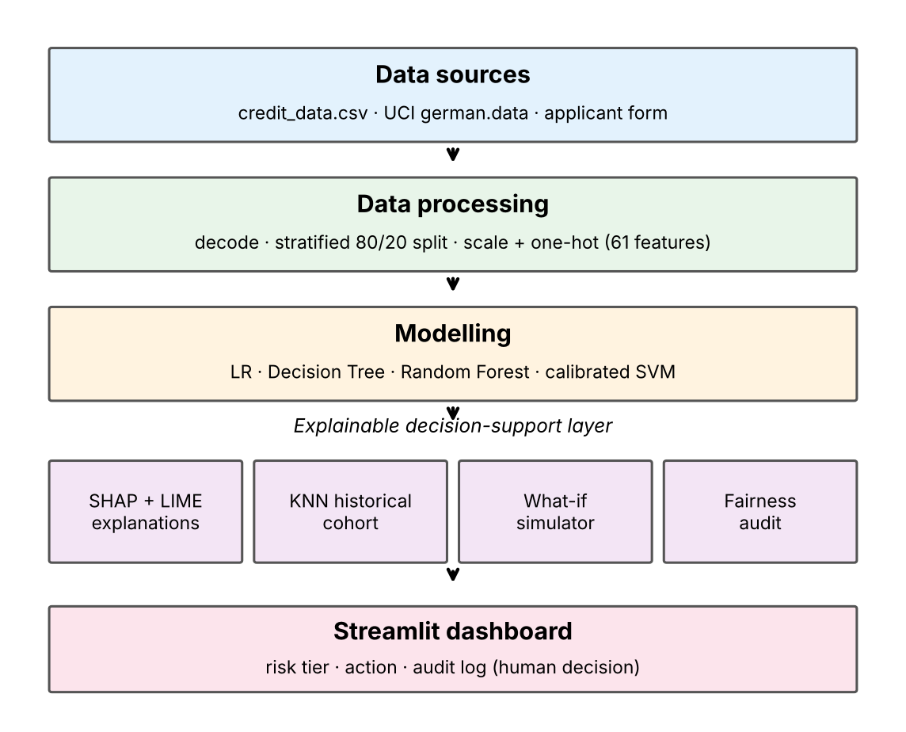
Fig.. Architecture of the proposed system.
B. Classifiers
Four classifiers were implemented with scikit-learn [9]; their configurations are listed in Table II. Logistic regression models the log-odds of default as a linear function of the features [2]:
P(y = 1 | x) = 1 / (1 + exp(−(w·x + b))) (1)
A decision tree recursively splits the feature space to reduce impurity; its depth is limited to five to avoid overfitting the small dataset. A random forest averages the votes of many trees, each trained on a bootstrap sample with random feature subsets [3]; the default probability is the mean of the tree-level probabilities:
P(y = 1 | x) = (1/B) Σ_b p_b(y = 1 | x), B = 150 (2)
A support vector machine with an RBF kernel finds a maximum-margin boundary [4]. Because the raw SVM output is not a probability, the model is wrapped in sigmoid (Platt) calibration with three-fold cross-validation [11], so that all four models produce comparable default probabilities.
TABLE II. MODEL CONFIGURATIONS
Model | Key settings
Logistic Regression | liblinear, C = 1.0, max_iter = 1000
Decision Tree | max_depth 5, min_split 10, min_leaf 5
Random Forest | 150 trees, max_depth 8, min_split 6, min_leaf 3
SVM | RBF kernel, sigmoid calibration, cv = 3
All models use balanced class weights, which scale the loss of each class inversely to its frequency. With a 70:30 split this penalises a missed defaulter about 2.3 times more than a false alarm during training, and it addresses the imbalance without altering the data distribution.
C. Evaluation metrics
Let TP be defaulters correctly flagged, FN defaulters missed, FP good applicants flagged and TN good applicants approved. We report:
Accuracy = (TP + TN) / (TP + TN + FP + FN) (3)
Precision = TP / (TP + FP) (4)
Recall = TP / (TP + FN) (5)
F1 = 2 · Precision · Recall / (Precision + Recall) (6)
together with the area under the ROC curve (AUC) [13], which measures how well a model ranks defaulters above good applicants independently of any threshold. Recall is the most business-relevant measure because it is the proportion of defaulters that the system catches. Since a missed defaulter is estimated to cost about five times more than a rejected good applicant [12], we weight recall and AUC alongside accuracy when selecting a model.
D. Risk tiering
Because default risk is probabilistic, the predicted probability p is mapped to three actionable tiers: Low risk (p < 0.28), Medium risk (0.28 ≤ p < 0.58) and High risk (p ≥ 0.58). The lower threshold lies just below the 30% base default rate, so Low-risk applicants are those with clearly below-average risk. The upper threshold is set at a level at which the applicant is roughly twice as likely to default as an average borrower. Each tier carries a recommended action: standard or fast-track approval, manual underwriter review with proof of income or a guarantor, or decline/secured collateral.
E. Explainability and decision support
For the tree ensemble, exact Shapley values are computed with the SHAP TreeExplainer [7]. The prediction is decomposed as
f(x) = φ₀ + Σ_j φ_j(x) (7)
where φ₀ is the base risk and φ_j is the contribution of feature j, positive if it raises the default probability and negative if it lowers it. A narrative generator converts the largest contributions into plain-language sentences. LIME [8] fits a local linear surrogate on perturbed copies of the applicant as an independent check on the main drivers.
A historical cohort module uses nearest-neighbour search (Euclidean distance on the processed features, k from 3 to 15) to retrieve similar past borrowers and to report how many repaid or defaulted and their average loan amount and duration. The search uses features only, without access to outcomes, so it does not leak the target. A what-if simulator re-scores a modified copy of the application, for example a smaller amount, a shorter term or the addition of a guarantor, and reports the change ΔP in default probability and any change in risk tier. Finally, a fairness module computes approval rates for each group and the disparate impact ratio
DI = Approval(group A) / Approval(group B) (8)
where approval means a predicted good borrower. A ratio below 0.80 is flagged as potential adverse impact; the demographic parity difference is also reported. Groups examined are gender, age (<25 vs ≥25) and foreign-worker status.
Table E lists the notation used in the equations and tables of this paper.
TABLE E. NOTATION
Symbol | Meaning
x | Feature vector of an applicant (61 features)
y | Outcome: 0 = repaid, 1 = default
p | Predicted default probability P(y = 1 | x)
B | Number of trees in the random forest (150)
φ_j | SHAP contribution of feature j
TP, FP, TN, FN | Confusion-matrix counts (default = positive)
DI | Disparate impact ratio of approval rates
k | Number of neighbours in the cohort search
AUC / AP | Area under ROC / precision–recall curves

F. Overall procedure
The complete procedure can be summarised in seven steps. (1) Load the credit data and decode the categorical codes. (2) Split the data into stratified training and test sets. (3) Fit the scaler and encoder on the training set only and transform both sets. (4) Train the four classifiers with balanced class weights and evaluate them on the hold-out set and by cross-validation. (5) Select the primary model using discrimination, default recall, calibration and explainability, and store it with the preprocessor. (6) For a new applicant, apply the stored preprocessor, compute the default probability, assign the risk tier and generate the SHAP and LIME explanations, the historical cohort and, on request, what-if scenarios. (7) Periodically audit approval rates for fairness and write every assessment to the audit log. Steps 1 to 5 are performed offline when the models are built or retrained, and steps 6 and 7 are performed online for each application.

IV. DATASET AND PREPROCESSING
A. Dataset description
The Statlog German Credit dataset [10] contains 1,000 borrower records with 20 attributes and a binary outcome. The target is 0 for a good borrower who repaid (700 records) and 1 for a defaulter (300 records), a default rate of 30% (Fig. 1). The dataset has no missing values and no duplicate records, so no imputation or record removal was required. Categorical attributes are supplied as codes (for example, A11 for a checking balance below 0 DM); we mapped all 13 categorical attributes to readable labels so that explanations and the user interface are intelligible.
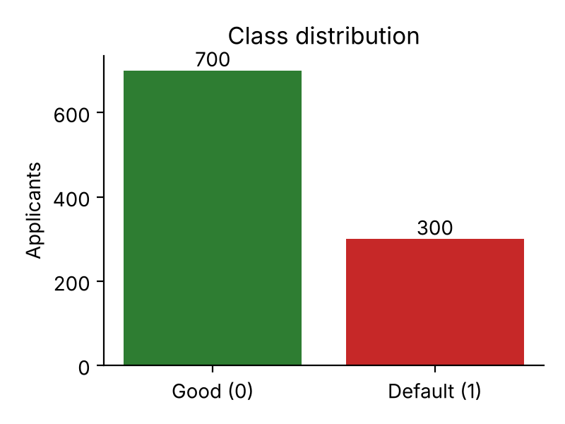
Fig. 1. Class distribution of the target variable.
TABLE I. NUMERICAL ATTRIBUTES
Attribute | Min | Mean | Max
Duration (months) | 4 | 20.9 | 72
Credit amount (DM) | 250 | 3,271 | 18,424
Installment rate | 1 | 3.0 | 4
Years at residence | 1 | 2.8 | 4
Age (years) | 19 | 35.5 | 75
Existing credits | 1 | 1.4 | 4
Dependents | 1 | 1.2 | 2

The 13 categorical attributes are checking status (4 levels), credit history (5), purpose (10), savings status (5), employment (5), personal status and sex (4), other parties (3), property (4), other payment plans (3), housing (3), job (4), telephone (2) and foreign-worker status (2). One-hot encoding expands them into 54 binary columns, so that together with the 7 numerical attributes each applicant is described by 61 features.
B. Exploratory data analysis
Exploratory analysis shows strong and interpretable relationships between applicant characteristics and default. Applicants with no checking account default least (11.7%), applicants with a balance of at least 200 DM default at 22.2%, those with a balance of 0 to 200 DM at 39.0%, and overdrawn applicants (<0 DM) default most (49.3%) (Fig. 2). Default rate also rises steadily with loan duration, from 21.2% for loans of up to 12 months to 29.7% for 13–24 months, 39.9% for 25–36 months and 51.7% for loans longer than 36 months (Fig. 3). Credit history, savings, age and credit amount are also informative. These patterns confirm that the data contain a learnable signal and anticipate the drivers later identified by the models.
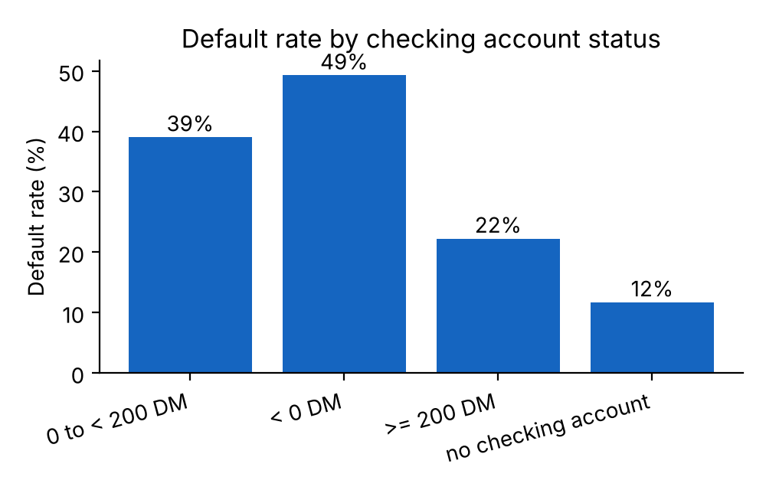
Fig. 2. Default rate by checking-account status.

Several other attributes show similarly strong gradients (Fig. 4 and Fig. 5). Savings status behaves as expected: applicants with at least 1,000 DM in savings default at only 12.5% and those with 500 to 1,000 DM at 17.5%, compared with 36.0% for those with under 100 DM, and applicants with no known savings account default at 17.5%. Employment length shows a similar pattern, with 40.7% default for those employed under one year, 22.4% for 4 to 7 years and 25.3% for 7 years or more. Housing and property also matter: 26.1% of homeowners default compared with 39.1% of renters and 40.7% of those living for free, and applicants with real estate default at 21.3% compared with 43.5% of those with no known property.
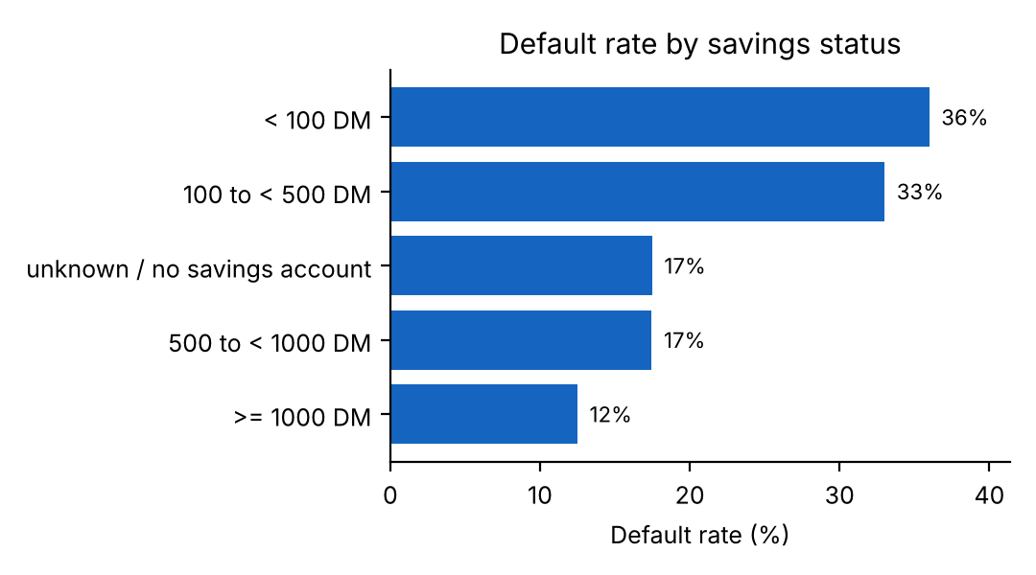
Fig. 4. Default rate by savings status.
Credit history shows a counter-intuitive pattern that is well known for this dataset (Fig. 5). Applicants with a critical account or other credits existing default least (17.1%), while those who have taken no credits or have paid all credits at the bank duly default most (62.5% and 57.1%, though these two groups contain only 40 and 49 applicants). A plausible explanation is selection in how the sample was collected, not a causal effect: a model trained on this data learns the association as it is, which is a clear example of why SHAP attributions must be interpreted as statements about the data and not as advice about behaviour. By purpose, education loans (44.0%) and new-car loans (38.0%) have the highest default rates, and used-car loans (16.5%) and radio or television purchases (22.1%) the lowest.
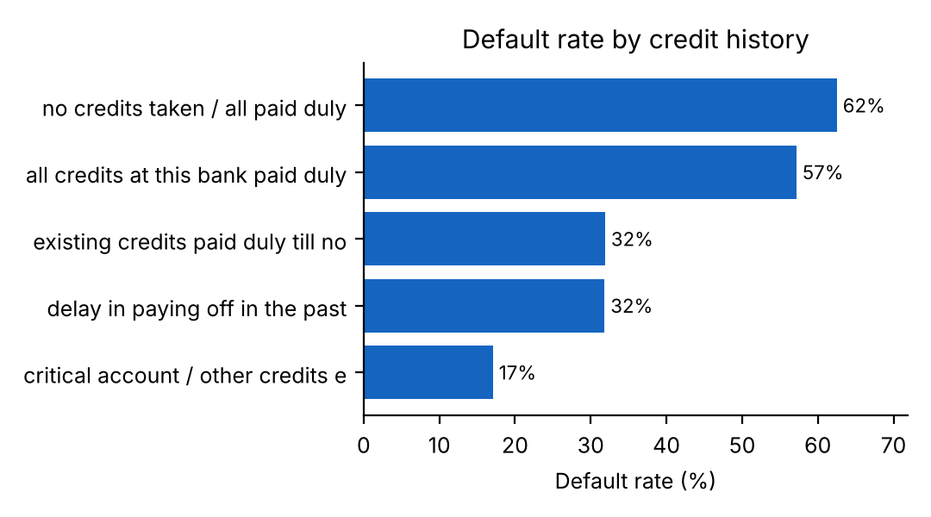
Fig. . Default rate by credit history.
TABLE IA. DEFAULT RATE BY AGE GROUP AND LOAN AMOUNT
Age | n | Default | Amount (DM) | n | Default
< 25 | 149 | 40.9% | ≤ 1,500 | 306 | 28.8%
25–34 | 399 | 32.8% | 1,500–3,000 | 314 | 24.8%
35–44 | 251 | 23.1% | 3,000–5,000 | 192 | 29.2%
45–54 | 122 | 23.0% | 5,000–8,000 | 118 | 33.9%
55+ | 79 | 27.8% | > 8,000 | 70 | 54.3%

Table IA shows that default risk is highest for the youngest applicants (40.9%) and falls to about 23% in the 35 to 54 age bands, and that it rises sharply for very large loans (54.3% above 8,000 DM). Among numerical attributes, duration and credit amount are positively correlated (r = 0.625), because longer loans tend to be larger, and both correlate positively with default (r = 0.215 and r = 0.155), whereas age has a weak negative correlation (r = −0.091). The moderate correlation between duration and amount is not a concern for tree-based models, but it is one reason why linear model coefficients should be interpreted with care. Together, these findings show that default is driven by combinations of weak signals rather than one dominant attribute, which motivates the use of nonlinear models and per-case explanation.
C. Leakage-free preprocessing
The data were split 80/20 with stratification on the target (random seed 42), giving 800 training and 200 test records and preserving the 30% default rate in both. Numerical attributes were standardised and categorical attributes one-hot encoded with unknown categories ignored. Crucially, both transformers were fitted on the training split only and then applied unchanged to the test split and to every new applicant, so no information from the test set influences training. The fitted transformer is serialised and reused by the application so that new applicants are processed exactly as the training data were.
We chose one-hot encoding for categorical attributes because their levels are nominal and, in several cases, non-monotonic in risk, as the credit-history result in Section III-B shows; ordinal codes would impose an artificial order. Standardisation of numerical attributes is not required by tree-based models but is important for logistic regression and the RBF-kernel SVM, which are sensitive to feature scale, and applying one common preprocessing pipeline to all models keeps the comparison fair. Unknown categories at prediction time are encoded as all-zero vectors so that the application does not fail on unexpected input. No outliers were removed: the largest loans (up to 18,424 DM) are legitimate records with a high default rate (Table IA) and removing them would discard exactly the cases that matter for risk.
V. SYSTEM IMPLEMENTATION
The system is implemented in Python 3 as independent modules fo
r configuration, data processing, model training, explainability, cohort matching, fairness evaluation and audit logging. Trained models, the fitted preprocessor, metrics, confusion matrices and ROC data are serialised with joblib, so the application starts without retraining. The dashboard has six modules: applicant assessment, explainable AI, historical cohort analysis, what-if simulation, model performance with fairness audit, and an assessment history. The assessment form is divided into loan terms, banking and liquidity, and demographics and collateral. For each applicant the interface shows the default probability, risk tier, recommended action, SHAP contribution chart, LIME check and narrative.
Each assessment is written to an audit log containing an anonymous identifier, a timestamp, the main loan terms, the tier, the probability and the key drivers; no personal identifiers are stored. A nine-test automated suite verifies dataset integrity, the preprocessing pipeline, prediction by all four models, risk tiering, SHAP and narrative generation, LIME, the cohort matcher, the fairness evaluator and the history store. The tool is intended strictly as decision support and displays a disclaimer that statistical attributions are not causal proof.
In practice the system supports the following analyst workflow (Table XI). The analyst enters the applicant’s data and receives the default probability and tier; reads the SHAP narrative and the LIME check to see which factors drive the score; consults the historical cohort to see how similar borrowers actually behaved; uses the what-if simulator to test whether a smaller amount, a shorter term, more savings or a guarantor would change the outcome; and finally records a decision. Every step is written to the audit log so that the decision can be reviewed later. Because the whole pipeline runs on a standard laptop and trains in seconds, institutions can retrain and revalidate the models frequently without special infrastructure.
TABLE XI. RISK TIERS AND RECOMMENDED ACTIONS
Tier | P(default) | Recommended action
Low | < 0.28 | Standard or fast-track approval
Medium | 0.28–0.58 | Manual review, proof of income or guarantor
High | ≥ 0.58 | Decline or require secured collateral

The code base follows a layered, modular design (Table XVI). Each module has a single responsibility and can be tested separately, which is what allows the nine-test suite to exercise the whole system quickly. Streamlit renders the interface directly from Python (the main application file has more than 1,100 lines), so analysts use the tool through a browser without any installation beyond Python.
TABLE XVI. SOFTWARE MODULES
Module | Responsibility
config | Schemas, category options, tier thresholds
data_processor | Decoding, profiling, preprocessing, split
model_trainer | Training, metrics, ROC, model persistence
xai_engine | SHAP, LIME, narrative, contribution plots
historical_matcher | Nearest-neighbour cohort and outcomes
fairness_evaluator | Approval rates, DI, parity difference
history_store | Privacy-preserving audit log
app | Six-module Streamlit dashboard

The assessment screen is organised to reduce data-entry effort and errors. Inputs use drop-down lists restricted to valid categories (for example, only the four valid checking-account levels) and bounded numeric ranges taken from the dataset, so malformed applications cannot reach the model. After submission, the interface shows the risk tier as a colour-coded card with the probability and the recommended action, followed by the SHAP contribution chart sorted by magnitude, so that the two or three strongest risk-raising and risk-lowering factors are visible at once. The model-performance screen reports the metrics table, ROC curves and confusion matrices, and the fairness screen reports approval rates and disparate impact per group together with an explicit flag when a ratio is below 0.80. The history screen lists previous assessments for review.
Three usage scenarios illustrate how the tiers translate into operations. In the first, a long-standing customer with a clean record and modest request is scored as Low risk; the analyst checks the explanation and cohort, confirms that no unusual factor drives the score, and approves the loan on a fast track, which saves review time for routine cases. In the second, an applicant with mixed signals, such as a large amount over a long term but with substantial savings and a guarantor, is scored as Medium risk; the analyst studies the cohort outcomes, runs what-if scenarios on the amount and term, and may approve with conditions or request additional documents. In the third, an applicant with an overdrawn account, a very long term, a large amount and little savings is scored as High risk with most nearest neighbours having defaulted; the analyst declines the application or asks for secured collateral and records the reasons in the audit log. In all three scenarios the system structures the review, and the decision remains a human responsibility.
VI. EXPERIMENTAL SETUP
All experiments use the same stratified 80/20 split (800 training and 200 test applicants; the test set has 60 defaulters and 140 good applicants). Models are trained on the training set and evaluated on the test set, which is never used for fitting transformers or models. To check that conclusions do not depend on one particular split, we additionally run five-fold stratified cross-validation on all 1,000 records, with the preprocessing fitted inside each training fold. Experiments were run with Python 3.12 and scikit-learn [9]; random seeds are fixed at 42 so that results are reproducible. The code, trained artifacts, dataset file and a nine-test suite are organised in a single project folder, and the system is launched with a single command (streamlit run app.py) after installing the listed dependencies. Metrics reported in Section VII were regenerated from this code and, for the hold-out set, match the stored evaluation file exactly.
VII. RESULTS AND DISCUSSION
A. Hold-out performance
TABLE III. HOLD-OUT PERFORMANCE (N = 200)
Model | Acc. | Prec. | Recall | F1 | AUC
Logistic Regression | 0.750 | 0.558 | 0.800 | 0.658 | 0.806
Decision Tree | 0.560 | 0.373 | 0.683 | 0.482 | 0.598
Random Forest | 0.730 | 0.538 | 0.717 | 0.614 | 0.797
SVM (calibrated) | 0.780 | 0.691 | 0.483 | 0.569 | 0.811

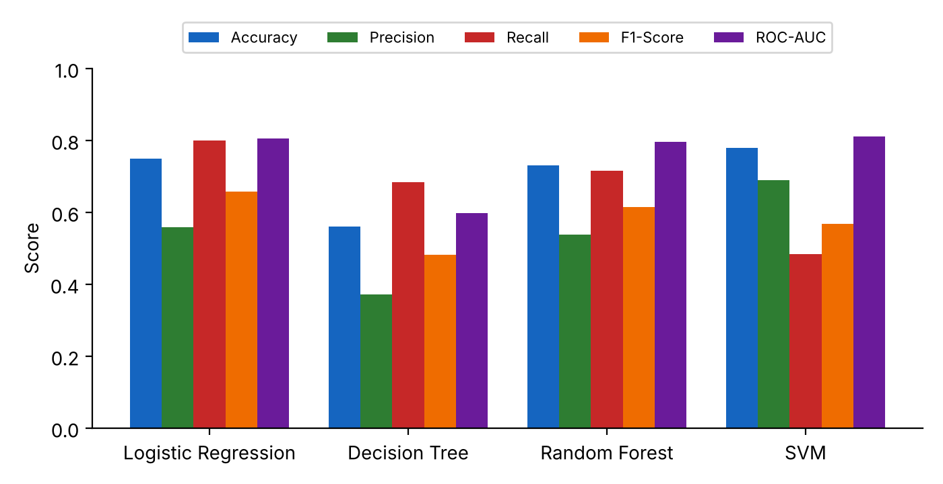
Fig. . Comparison of the four classifiers on all metrics.
Table III and Fig. 7 summarise the results. The SVM has the highest accuracy (78.0%) and ROC-AUC (0.811) but misses 31 of the 60 defaulters (recall 48.3%); in a setting where a missed default is far costlier than an extra review, this is a serious weakness. Logistic regression has the highest recall (80.0%) and an AUC of 0.806, showing that a well-regularised linear model is a strong baseline on this dataset, which agrees with the finding that simple models are often competitive on small credit datasets [5]. The decision tree is clearly the weakest (AUC 0.598) because a single shallow tree cannot capture the interactions in the data. Random forest offers near-best discrimination (AUC 0.797) with recall of 71.7%.
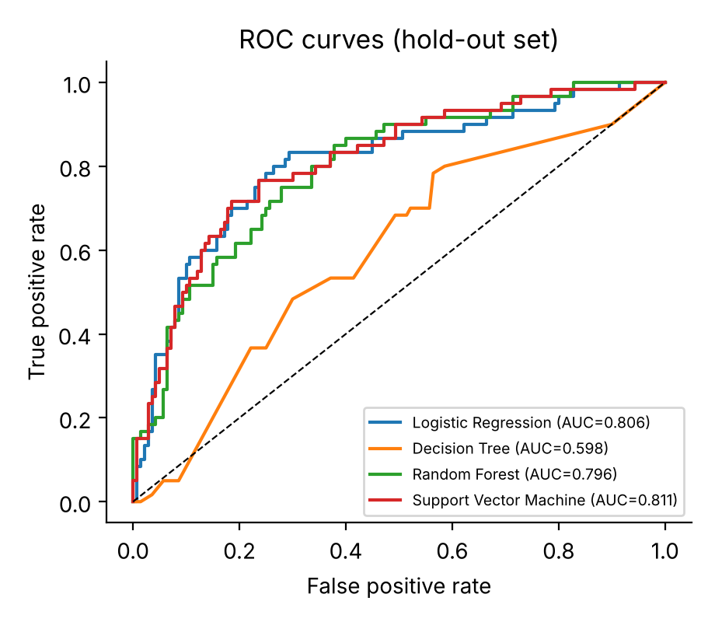
Fig. 8. ROC curves of the four classifiers on the hold-out set.
The ROC curves in Fig. 8 show that logistic regression, random forest and the SVM are close to each other and far above the decision tree. The confusion matrices (Fig. 9) make the cost trade-offs explicit. Random forest correctly flags 43 defaulters and misses 17, approves 103 good applicants and refers 37 for review. The SVM refers only 13 good applicants but misses 31 defaulters, while the decision tree refers 69 good applicants, which would overload underwriters.
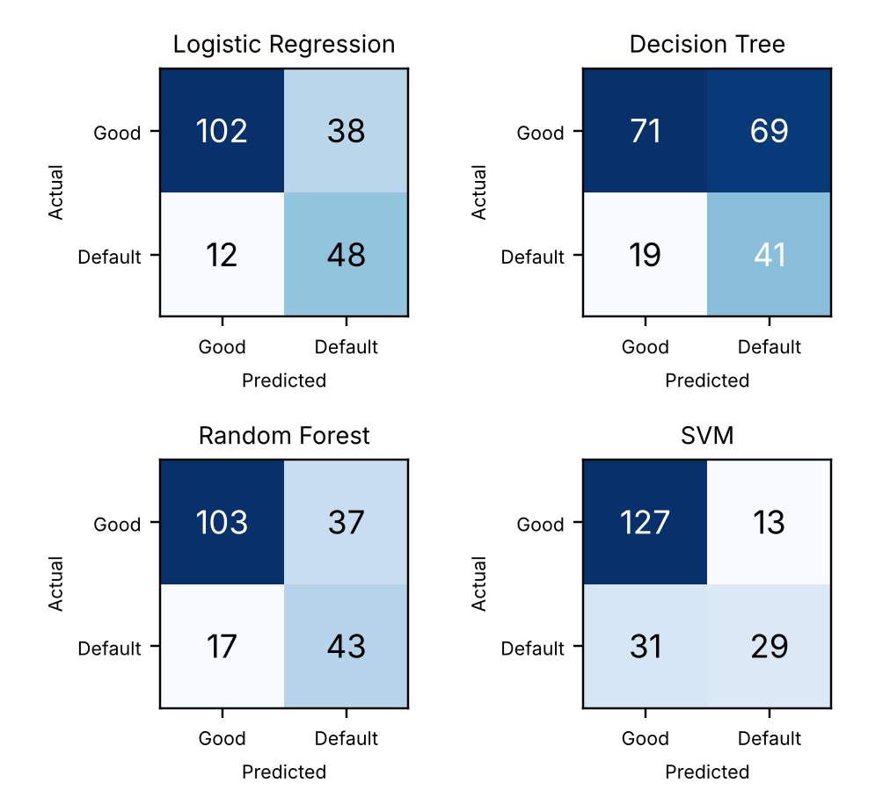
Fig. 9. Confusion matrices of the four classifiers.
B. Cross-validation
TABLE IV. FIVE-FOLD CROSS-VALIDATION (MEAN ± SD)
Model | Acc. | Recall | F1 | AUC
Log. Regression | 0.719±0.027 | 0.720±0.041 | 0.606±0.034 | 0.786±0.019
Decision Tree | 0.646±0.039 | 0.657±0.075 | 0.526±0.026 | 0.682±0.025
Random Forest | 0.724±0.026 | 0.687±0.019 | 0.600±0.019 | 0.793±0.023
SVM | 0.762±0.009 | 0.423±0.048 | 0.515±0.038 | 0.794±0.012

Table IV shows that the main conclusions hold across folds. The ranking by AUC is SVM (0.794), random forest (0.793), logistic regression (0.786) and decision tree (0.682), and the first three are within one standard deviation of each other, so their discrimination is statistically similar. The SVM again has the highest accuracy but the lowest recall (0.423), while the decision tree is weakest. Random forest has the lowest variance in recall (SD 0.019), indicating stable default detection. The cross-validated recall of random forest (0.687) is slightly lower than its hold-out value (0.717), a reminder that a single 200-record test set gives a noisy estimate, and that differences of a few percentage points between models should not be over-interpreted.
C. Model selection
Random forest was selected as the primary model for three reasons: (i) its discrimination is statistically indistinguishable from the best models on both the hold-out set and cross-validation; (ii) it detects about 70% of defaulters, far more than the SVM; and (iii) it supports the exact TreeExplainer algorithm for SHAP [7], which is essential for the explainability layer. Logistic regression remains a valid, more interpretable alternative and is retained as a baseline. The choice illustrates that, in credit risk, model selection should consider recall, explainability and auditability in addition to accuracy.
D. Threshold analysis
Fig. 10 shows how recall and precision of the random forest change as the decision threshold on the default probability moves. At the default threshold of 0.50 the model reaches recall 0.717 and precision 0.537 (17 missed defaulters, 37 false alarms). Lowering the threshold to 0.40 raises recall to 0.867 and reduces missed defaulters to 8, at the price of 64 false alarms and precision of 0.448. Raising it to 0.65 reduces false alarms to 9 but misses 35 defaulters. Table V lists these operating points.
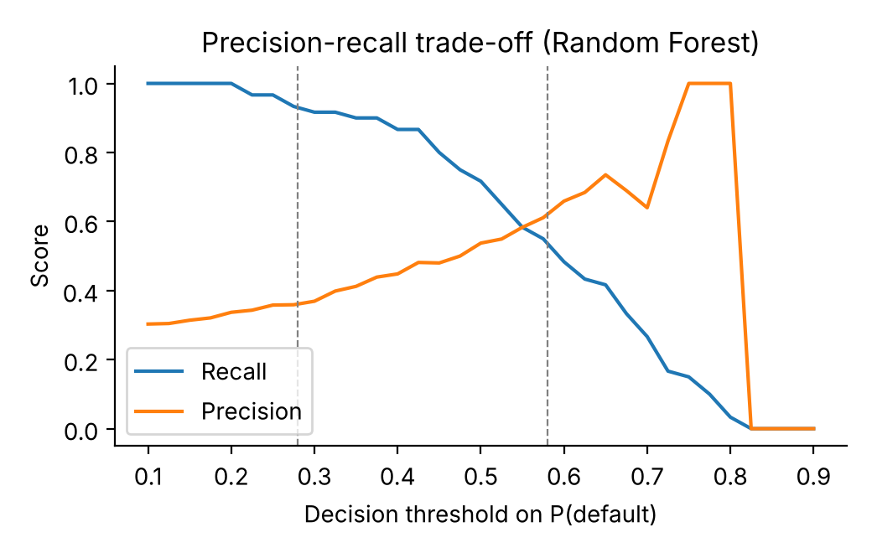
Fig. 10. Precision–recall trade-off of the random forest as the threshold varies.
TABLE V. RANDOM FOREST OPERATING POINTS (TEST SET)
Thr. | Prec. | Recall | F1 | Missed | False
0.28 | 0.366 | 0.933 | 0.526 | 4 | 97
0.40 | 0.448 | 0.867 | 0.591 | 8 | 64
0.50 | 0.537 | 0.717 | 0.614 | 17 | 37
0.58 | 0.596 | 0.517 | 0.554 | 29 | 21
0.65 | 0.735 | 0.417 | 0.532 | 35 | 9

Because a missed defaulter is about five times costlier than a false alarm, the cost-weighted error (missed × 5 + false) is 5·4+97 = 117 at threshold 0.28, 5·8+64 = 104 at 0.40, 5·17+37 = 122 at 0.50, 5·29+21 = 166 at 0.58 and 5·35+9 = 184 at 0.65. Under this assumption a threshold near 0.40 would minimise expected cost on this test set, which suggests that the default 0.50 operating point is not cost-optimal. Because the test set is small and the 5:1 ratio is an assumption, an institution should tune the threshold on its own data and cost estimates; this is a promising direction for future work.
E. Validation of the risk tiers
TABLE VI. OBSERVED DEFAULT RATE BY RISK TIER (TEST SET)
Tier | Range | Applicants | Observed default
Low | p < 0.28 | 47 | 8.5%
Medium | 0.28–0.58 | 101 | 24.8%
High | p ≥ 0.58 | 52 | 59.6%

A useful tier system must be well ordered: higher tiers must contain more actual defaulters. Table VI shows that this holds. Of the 47 applicants in the Low tier only 8.5% defaulted, far below the 30% base rate; the Medium tier (101 applicants) has an observed default rate of 24.8%, close to the base rate; and the High tier (52 applicants) has 59.6%, twice the base rate. The monotone increase confirms that the thresholds separate applicants into meaningfully different risk groups. The Medium tier is the largest, as intended: it contains borderline cases that require human review rather than automatic action.
F. Key drivers of default
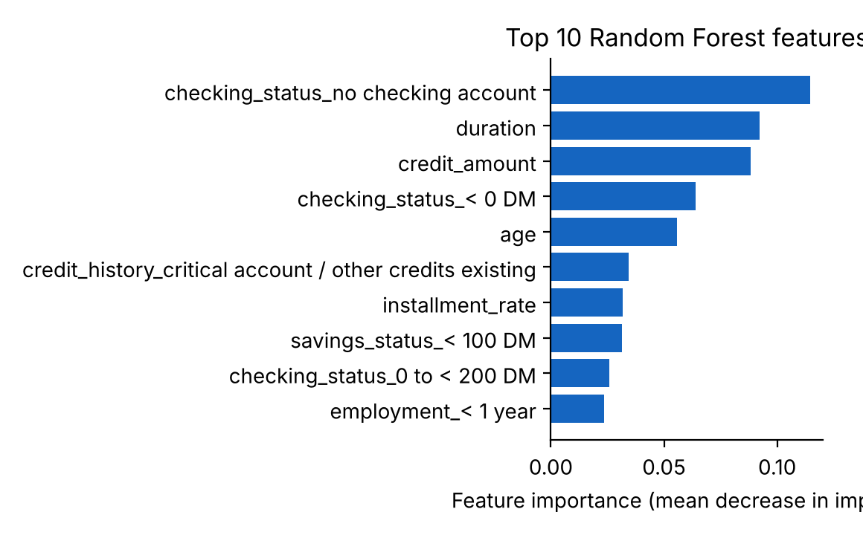
Fig. 11. Top-10 random forest feature importances (impurity-based).
Fig. 11 shows the impurity-based importances of the encoded features. The random forest ranks checking-account status (no checking account, 0.114; overdrawn, 0.064), loan duration (0.092), credit amount (0.088) and age (0.056) highest, consistent with the exploratory analysis. Impurity-based importance can be biased toward features with many distinct values, so we cross-checked it with permutation importance on the test set, which measures how much the ROC-AUC falls when one original attribute is shuffled (Fig. 12). Checking status is by far the most important attribute (AUC decrease 0.131), followed by credit amount (0.012), duration (0.012), purpose (0.011) and credit history (0.010). Both views agree that the state of the applicant’s checking account is the dominant signal, and that loan size and term are the main secondary drivers.
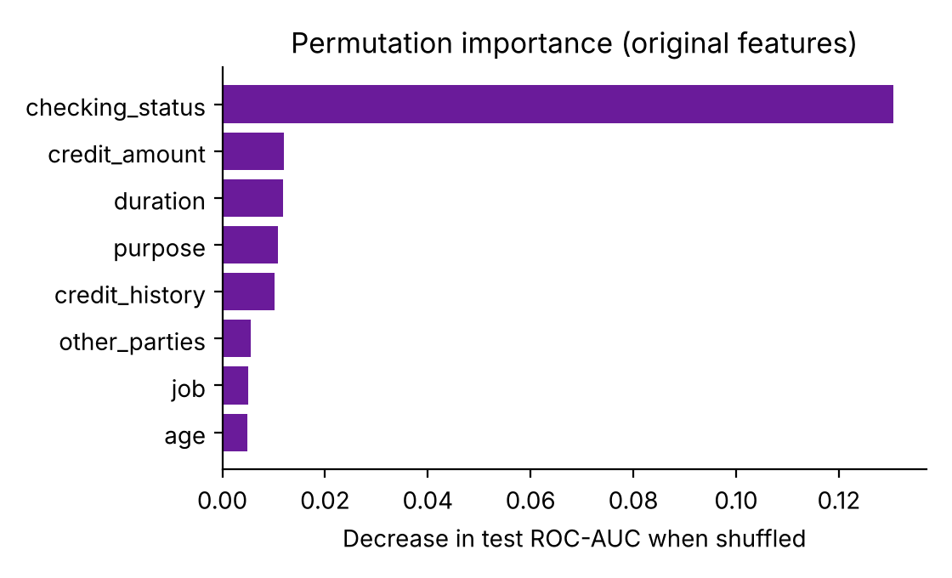
Fig. 12. Permutation importance of the original attributes on the test set.
These global findings are what SHAP reports locally for each applicant. For example, an applicant with a stable checking account and a short loan term receives negative (risk-reducing) contributions from those features, while a long, large loan with low savings receives positive contributions. The narrative generator turns these values into sentences that an analyst can verify and that can be recorded in the audit log.
G. Fairness audit
TABLE VII. FOUR-FIFTHS-RULE AUDIT OF THE RANDOM FOREST
Group A vs B | App. A | App. B | DI | Status
Female vs male | 0.557 | 0.619 | 0.901 | OK
Age <25 vs ≥25 | 0.410 | 0.646 | 0.635 | Flag
Foreign vs domestic | 0.593 | 0.833 | 0.711 | Flag*

Table VII reports approval rates on the 200-record test set. Gender parity is acceptable: the approval rate for women (55.7%, n = 61) is 90.1% of that for men (61.9%, n = 139), above the 80% guideline. Applicants under 25 (n = 39) are approved far less often (41.0%) than older applicants (64.6%, n = 161); the ratio of 0.635 is well below 0.80 and demographic parity difference is 0.236. This is a genuine warning. It may partly reflect real differences in repayment behaviour (young applicants have shorter credit histories), but a lender cannot treat a statistical association as justification without further review. The foreign-worker ratio (0.711) rests on only six domestic workers in the test split, so it is statistically unreliable. Equal approval rates are not the only possible fairness criterion [15], but the four-fifths rule serves as a transparent first screen that already identified an issue worth investigating before any real deployment.
H. Case study: assessment, cohort and what-if
To show how the decision-support layer works for a single case, we scored two illustrative applicants with the trained random forest. Applicant A is a 35-year-old skilled employee requesting 3,500 DM over 24 months for a new car, with 0 to 200 DM in the checking account, 100 to 500 DM of savings, 1 to 4 years of employment, real estate and a clean repayment record. The model returns a default probability of 0.357, a Medium-risk assessment that triggers manual review. Only 1 of A’s 10 nearest historical borrowers defaulted, which supports the view that A is a moderate, not a high, risk.
Applicant B is a 22-year-old with less than one year of employment who requests 9,000 DM over 48 months for a used car, is overdrawn (<0 DM), has under 100 DM of savings and a critical account with other credits existing. The model returns 0.571, at the very top of the Medium tier and just below the 0.58 High-risk threshold, and 7 of B’s 10 nearest historical borrowers defaulted. The analyst can then use the what-if simulator to explore how B’s risk would change (Table VIII).
TABLE VIII. WHAT-IF ANALYSIS FOR APPLICANT B
Change to B | P(default) | ΔP
None (baseline) | 0.571 | —
Duration 48 → 12 months | 0.442 | −0.129
Amount 9,000 → 2,000 DM | 0.454 | −0.117
Savings → ≥ 1,000 DM | 0.406 | −0.165
Checking → no account | 0.478 | −0.093
Add a guarantor | 0.553 | −0.018
Duration 24, amount 5,000, guarantor, savings 500–1,000 DM | 0.335 | −0.236

The simulation shows that, for this profile, improving savings, shortening the term and reducing the amount lower the risk the most, while adding a guarantor alone changes little. A combination of a 24-month term, a 5,000 DM amount, a guarantor and moderate savings reduces the probability from 0.571 to 0.335. Such counterfactual information is useful because it tells the analyst what conditions, such as a smaller loan or a shorter term, would make the application acceptable, rather than only returning a refusal. The simulator also reminds the user that these are statistical associations from the model and do not guarantee approval.
I. Error analysis
To understand where the random forest fails, we compared the 17 defaulters it missed with the 43 it caught. The two groups look different in a way that is easy to interpret. Caught defaulters tend to have longer loans (mean 29.3 months versus 18.8 months for missed defaulters) and higher installment rates (3.4 versus 2.5), and 28 of the 43 are overdrawn (<0 DM). Missed defaulters mostly resemble good borrowers: 7 have no checking account, the category with the lowest overall default rate (11.7%), and 7 more have a balance of 0 to 200 DM; their average predicted probability is only 0.385 compared with 0.657 for the caught group. Nine of the 17 missed cases are loans for a new car. In other words, the model misses defaulters whose recorded attributes look ordinary, which is an inherent limit of a dataset of 20 coarse attributes: no model can detect a default that the available data do not reveal. Additional behavioural and transaction-level data, as suggested by Khandani et al. [6], are the most promising way to reduce such misses.
The 37 false alarms show the opposite pattern. Their mean loan duration (23.2 months) is longer than that of correctly approved good applicants (17.9 months), and 19 of them are overdrawn. These are good borrowers whose profile resembles that of defaulters. Because these cases fall mainly in the Medium tier, the manual-review step of the proposed workflow is the appropriate place to resolve them, using the cohort evidence and the what-if analysis rather than automatic rejection.
J. Ablation and sensitivity analysis
We examined how much the main design choices matter. First, we removed class weighting and retrained all four models (Table IX). Balancing greatly increases default recall for the models whose predictions it affects: random forest recall rises from 0.400 to 0.717, logistic regression from 0.533 to 0.800 and the decision tree from 0.483 to 0.683. The price is lower accuracy and precision, for example 0.775 to 0.730 accuracy and 0.727 to 0.537 precision for random forest. ROC-AUC barely changes, because class weights alter the decision boundary rather than the ranking of applicants. For the calibrated SVM, weighting does not change recall at the 0.50 cut-off (0.483 in both cases), and its AUC rises from 0.795 to 0.811. Without balancing, the random forest would have missed 36 of 60 defaulters instead of 17, which confirms that class weighting is essential for a recall-oriented objective.
TABLE IX. EFFECT OF CLASS WEIGHTING (HOLD-OUT RECALL / ACCURACY)
Model | Recall (none) | Recall (balanced) | Acc. (none → bal.)
Logistic Regression | 0.533 | 0.800 | 0.780 → 0.750
Decision Tree | 0.483 | 0.683 | 0.675 → 0.560
Random Forest | 0.400 | 0.717 | 0.775 → 0.730
SVM | 0.483 | 0.483 | 0.780 → 0.780

Second, we varied the maximum depth of the random forest (Table X). Cross-validated AUC increases from 0.772 at depth 3 to 0.793 at depth 8 and then plateaus (0.791 at depth 12, 0.789 without a limit), while recall falls from 0.707 to 0.653 as deeper trees fit the training data more closely. Depth 8 therefore lies near the point where discrimination saturates, a reasonable compromise. Varying the number of trees from 50 to 300 changes AUC only from 0.791 to 0.795, so the 150 trees used are sufficient and the model is insensitive to this parameter.
TABLE X. RANDOM FOREST SENSITIVITY (5-FOLD CV)
Setting | AUC | Recall
max_depth = 3 | 0.772 | 0.707
max_depth = 5 | 0.781 | 0.707
max_depth = 8 (used) | 0.793 | 0.687
max_depth = 12 | 0.791 | 0.657
max_depth = none | 0.789 | 0.653
50 trees | 0.791 | 0.693
150 trees (used) | 0.793 | 0.687
300 trees | 0.795 | 0.683

Third, the learning curve in Fig. 13 shows that cross-validated AUC rises steadily with the amount of training data, from 0.742 with 160 records to 0.793 with 800 records, and has not yet flattened. The training AUC stays much higher (0.961 at 800 records), which indicates some overfitting typical of random forests on small data. Both observations support the expectation that a larger portfolio would improve performance and that results on 1,000 records should be seen as a lower bound.
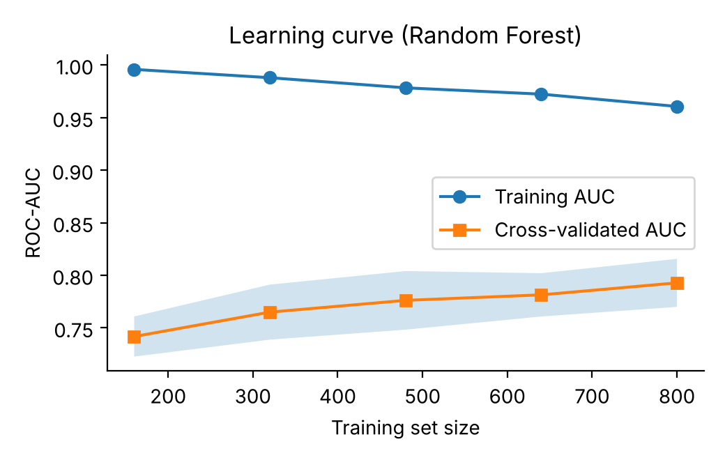
Fig. 13. Learning curve of the random forest (5-fold CV).
K. Probability calibration and precision–recall analysis
Because the tiers and the what-if simulator rely on predicted probabilities, the probabilities should be reliable, not merely well ranked. We assessed calibration with the Brier score (the mean squared error of the predicted probability; lower is better) and with a reliability diagram that compares the mean predicted probability in each quantile bin with the observed default rate (Fig. 14). The calibrated SVM has the best Brier score (0.157), followed by logistic regression (0.182) and random forest (0.183), while the decision tree is clearly worst (0.288) because its leaf probabilities are coarse. The sigmoid calibration applied to the SVM therefore achieves its goal. Random forest probabilities are slightly compressed toward the middle, as is typical of bagged trees, but they remain monotonic with the observed rate, which is the property that the tier validation in Table VI requires.
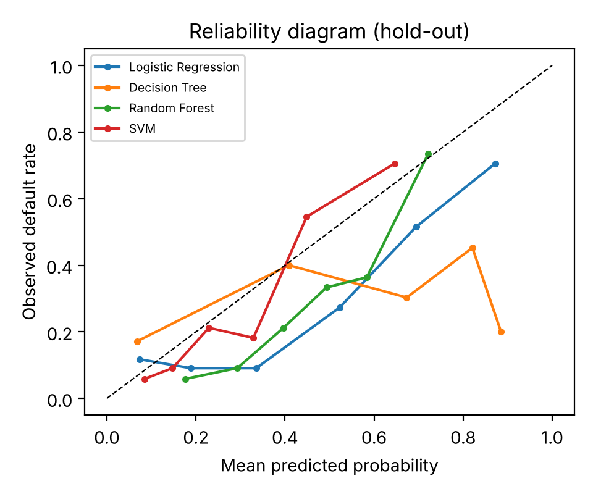
Fig. 14. Reliability diagram of the four classifiers on the hold-out set.
Since defaulters are the minority class, the precision–recall curve is more informative than the ROC curve about performance on the class of interest. Fig. 15 shows that the SVM, random forest and logistic regression have similar average precision (0.658, 0.645 and 0.633 respectively), all well above the 0.30 no-skill baseline given by the default rate, whereas the decision tree reaches only 0.369. The result agrees with the ROC analysis: the three stronger models are close and the single tree is much weaker.
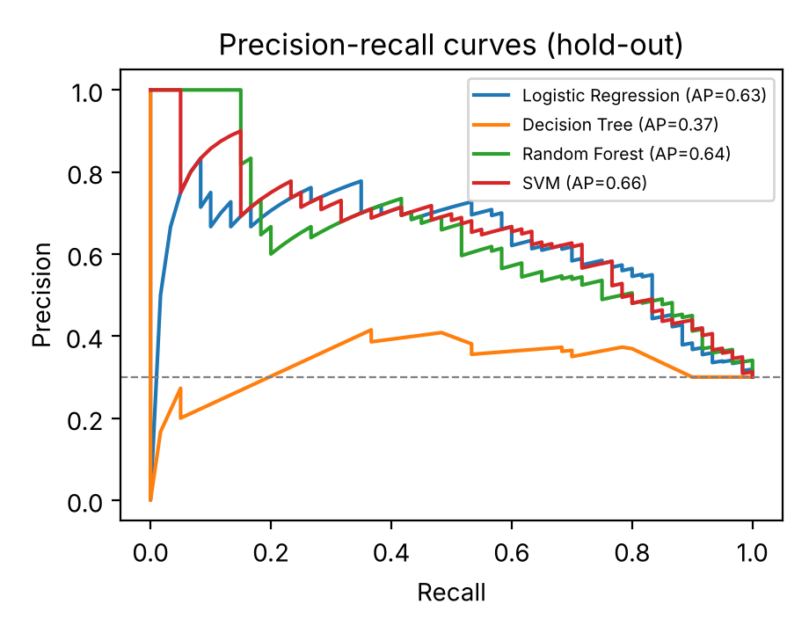
Fig. 15. Precision–recall curves of the four classifiers.
L. Statistical uncertainty and additional baselines
With only 200 test applicants, point estimates are uncertain. We therefore computed 95% bootstrap confidence intervals (2,000 resamples of the test set) for AUC and recall (Table XII). The AUC intervals of logistic regression [0.736, 0.870], random forest [0.733, 0.859] and the SVM [0.742, 0.873] overlap almost entirely, so the data cannot separate these three models, whereas the decision tree [0.516, 0.679] lies clearly below. The recall intervals are wide (for random forest, 0.603 to 0.828), and that of the SVM [0.359, 0.614] lies below those of the other models, which supports the earlier conclusion that its low default detection is real rather than a sampling artefact.
TABLE XII. 95% BOOTSTRAP INTERVALS (HOLD-OUT)
Model | AUC | Recall
Log. Regression | 0.736–0.870 | 0.691–0.899
Decision Tree | 0.516–0.679 | 0.561–0.800
Random Forest | 0.733–0.859 | 0.603–0.828
SVM | 0.742–0.873 | 0.359–0.614

We also compared the models directly with a paired bootstrap of the AUC difference. The mean AUC difference between random forest and logistic regression is −0.009 (95% interval −0.047 to 0.031), and between random forest and the SVM it is −0.014 (−0.045 to 0.014); both intervals contain zero, so neither difference is statistically significant. In contrast, random forest exceeds the decision tree by 0.199 (0.129 to 0.273), a significant gain. These results justify choosing among the three leading models on grounds other than AUC, namely recall, explainability and calibration, as done in Section VII-C.
To check that the four selected models are not missing an obviously better family, we trained three further baselines with the same preprocessing (Table XIII). Gradient boosting reaches a hold-out AUC of 0.792 and cross-validated AUC of 0.779, comparable to random forest but with lower recall (0.567 hold-out, 0.467 cross-validated) at the default threshold. The k-nearest-neighbour classifier (k = 15) is weaker (AUC 0.747) and detects only 36.7% of defaulters, and Gaussian naive Bayes has the highest recall of the three (0.650) but the lowest AUC (0.741). None of the extra baselines improves on the selected random forest in both discrimination and default detection, supporting the model choice on this dataset.
TABLE XIII. ADDITIONAL BASELINES
Model | Acc. | Prec. | Recall | AUC | CV AUC
Gradient Boosting | 0.795 | 0.694 | 0.567 | 0.792 | 0.779
k-NN (k = 15) | 0.755 | 0.667 | 0.367 | 0.747 | 0.743
Naive Bayes | 0.695 | 0.494 | 0.650 | 0.741 | 0.731

M. Sensitivity to the cost ratio
The 5:1 cost ratio used so far is an assumption, and different institutions will weigh errors differently. Fig. 16 plots the expected cost on the test set, defined as the cost ratio times the number of missed defaulters plus the number of false alarms, for ratios of 1:1, 3:1, 5:1 and 10:1. The cost-minimising threshold falls as the penalty on missed defaulters grows: 0.64 for 1:1, 0.44 for 3:1, 0.42 for 5:1 and 0.20 for 10:1. Compared with the default threshold of 0.50, tuning reduces the cost from 54 to 44 units at 1:1, from 88 to 80 at 3:1, from 122 to 97 at 5:1 and from 207 to 118 at 10:1. The saving is therefore largest when missed defaults are most expensive. This is a practical argument for exposing the threshold, and the three tier boundaries derived from it, as configurable parameters in the application.
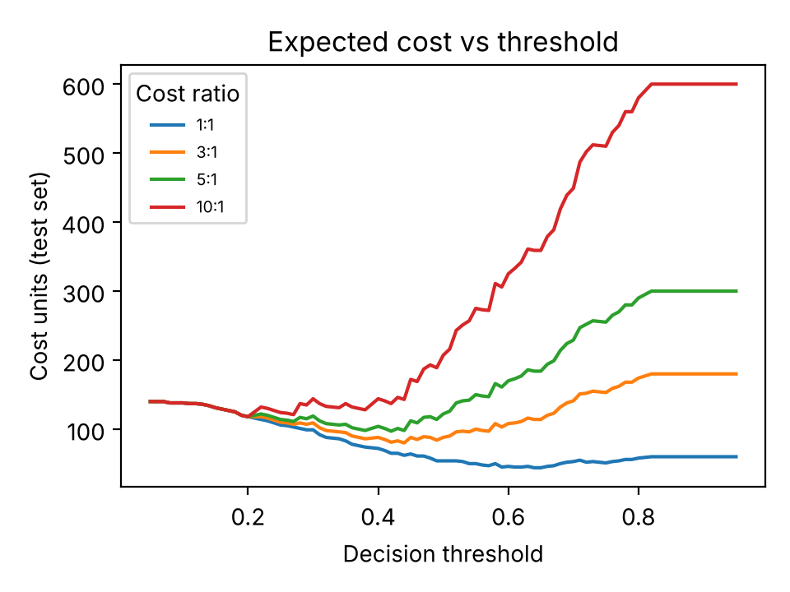
Fig. 16. Expected cost of the random forest versus decision threshold for four cost ratios.
N. Fairness: error rates and removal of sensitive attributes
The disparate impact ratio in Section VII-G compares approval rates but does not say whether the difference reflects different underlying risk. We therefore also compared error rates by group (Table XIV). Among applicants under 25, the observed default rate is 48.7% in the test set (and 40.9% in the full dataset, against 28.1% for older applicants), so some difference in approval is expected. The true-positive rate is similar for the two age groups (0.737 and 0.707), which means that the model catches defaulters about equally well in both groups, an equal-opportunity view [15] under which the model appears acceptable. However, the false-positive rate is 0.450 for applicants under 25 and 0.233 for older applicants, so young applicants who would have repaid are wrongly flagged almost twice as often. For gender the error rates are close (true-positive rates 0.750 versus 0.700 and false-positive rates 0.293 versus 0.253), consistent with the acceptable disparate impact. The approval-rate ratio for age has a wide bootstrap interval (0.40 to 0.90), so the disparity is likely but not certain.
TABLE XIV. ERROR RATES BY GROUP (TEST SET)
Group | n | Default rate | TPR | FPR
Age < 25 | 39 | 0.487 | 0.737 | 0.450
Age ≥ 25 | 161 | 0.255 | 0.707 | 0.233
Female | 61 | 0.328 | 0.750 | 0.293
Male | 139 | 0.288 | 0.700 | 0.253

Finally, we tested whether simply removing sensitive attributes reduces the disparity (Table XV). Dropping age leaves AUC unchanged (0.800 versus 0.797) and raises recall to 0.750, while the approval-rate ratio for applicants under 25 improves from 0.635 to 0.736. Dropping age, personal status and sex, and foreign-worker status together gives an AUC of 0.788 and a ratio of 0.751. The ratio still stays below the 0.80 guideline, because age is correlated with other attributes such as employment length, savings and loan purpose, which act as proxies. The experiment shows that sensitive inputs can be removed at almost no cost in accuracy, and that doing so reduces but does not remove the disparity, so a fairness audit remains necessary even when protected attributes are excluded. The deployed application keeps these inputs only because they are in the benchmark and are needed for the audit.
TABLE XV. EFFECT OF REMOVING SENSITIVE ATTRIBUTES
Inputs removed | Feat. | AUC | Recall | DI (age)
None | 61 | 0.797 | 0.717 | 0.635
Age | 60 | 0.800 | 0.750 | 0.736
Age, sex, foreign | 54 | 0.788 | 0.750 | 0.751

O. Validation of the historical cohort module
The cohort module is intended as independent, case-level evidence, so it is important to check that it carries real information. For each test applicant we retrieved the k most similar training borrowers and used the fraction of them who defaulted as a risk score, without using the random forest. The cohort score discriminates defaulters from good applicants with an AUC of 0.693 for k = 3, 0.729 for k = 5 and 0.747 for both k = 10 and k = 15, which is well above chance although below the random forest (0.797). Larger k gives more stable estimates, because with k = 3 a single borrower changes the score by a third, which is why the interface allows k between 3 and 15 and uses 10 by default. The cohort score is also consistent with the model: its Spearman rank correlation with the random forest probability rises from 0.526 at k = 3 to 0.670 at k = 10 and 0.715 at k = 15.
The average cohort default fraction (k = 10) increases across the model’s risk tiers, from 0.104 for Low-risk applicants to 0.262 for Medium and 0.469 for High, matching the ordering of the observed default rates in Table VI. The two views agree on whether the default probability is above or below 0.5 for 71% of test applicants. The cohort module therefore acts as a useful independent cross-check: where it agrees with the model, confidence is higher, and where it disagrees, the analyst is prompted to look more closely at the case. Since it is a purely descriptive retrieval of past cases, it also gives non-technical reviewers an intuitive explanation that does not depend on understanding model internals.
P. Computational cost
Because the system is meant to run on an analyst’s laptop, computational cost matters. On a standard CPU with the 800-record training set, training takes 0.004 s for logistic regression, 0.004 s for the decision tree, 0.075 s for the calibrated SVM and 0.257 s for the 150-tree random forest. Scoring the 200 test applicants takes 0.3 ms, 0.2 ms, 22.9 ms and 8.3 ms respectively, that is, well under a tenth of a second for a whole batch and a few tens of microseconds per applicant for the forest. The cost of SHAP explanation is also small for tree ensembles, because TreeExplainer computes exact values in polynomial time. These figures show that retraining, validation and per-case explanation can all be done interactively, and that the complexity of the random forest is not a practical obstacle.
Q. Discussion
The experiments lead to four practical lessons. First, accuracy is a misleading selection criterion in credit risk: the SVM has the best accuracy yet misses more than half of the defaulters. Second, on small tabular datasets simple models can match complex ones, so logistic regression is a strong baseline, and choosing among near-equal models should be driven by explainability and cost-sensitive behaviour. Third, the operating threshold should be tuned to the lender’s cost structure rather than fixed at 0.50. Fourth, high predictive performance does not guarantee equal treatment; a fairness audit should be part of every deployment, and the model should be used as decision support with a human in the loop. The cohort and what-if modules further support this by giving analysts concrete, case-level evidence to accept or override the model.
Based on these results, we suggest five practical recommendations for institutions adopting a similar system. First, report recall, calibration and cost-based measures alongside accuracy and AUC. Second, choose the operating threshold from the institution’s own cost ratio and review it periodically. Third, validate risk tiers against observed outcomes on a recent hold-out sample before use, and recheck them after each retraining. Fourth, include a fairness audit with both approval-rate and error-rate comparisons, and reconsider the use of sensitive attributes. Fifth, keep a human decision-maker and an audit trail in every workflow, using the explanation, cohort and what-if tools to support, and not to replace, professional judgement.
VIII. ETHICAL AND REGULATORY CONSIDERATIONS
Credit decisions affect access to housing, education and business opportunities, so the deployment of a predictive model carries obligations beyond statistical performance. First, the system is advisory: it never holds unilateral authority to reject an applicant, and each recommendation is intended to be reviewed by a qualified underwriter who can override it. Second, applicants are entitled to understand the main reasons behind an adverse decision, which the SHAP narratives and what-if results are designed to support, although they must be validated by the institution’s compliance team before use as formal adverse-action notices. Third, the dataset includes sensitive attributes such as personal status, sex, age and foreign-worker status. Using them as model inputs may be unlawful in some jurisdictions, and they appear here because they are part of the benchmark data and are needed to audit disparity; a production system should review which attributes are permissible and consider removing or constraining them. Fourth, audit logs are kept without personal identifiers to limit privacy risk. Finally, the German Credit data reflect historical lending conventions and cannot represent current practice; institutions must retrain and revalidate on localised, compliant portfolios.
IX. LIMITATIONS AND FUTURE WORK
The study has several limitations. The dataset is small (1,000 records), historical and from a single source, so the results may not generalise to other lenders, periods or countries; models should be retrained on local, compliant and debiased portfolios before use. The hold-out set has 200 records, which makes metrics noisy, as shown by the gap between hold-out and cross-validated recall. Hyperparameters were set to sensible values rather than tuned exhaustively, and gradient-boosting methods were not evaluated. The 5:1 cost ratio is an assumption. SHAP and LIME describe statistical associations in the trained model, not causal effects, and the fairness audit used small groups. The system has no authentication, database or drift monitoring and is not production hardened.
Threats to validity. Internal validity is threatened by the small test set and by the fact that hyperparameters were chosen once and not nested within cross-validation, so reported scores may be slightly optimistic. We limited this risk by fitting all transformers inside the training folds, by using a fixed split and seed, and by confirming conclusions with five-fold cross-validation. Construct validity is limited because the target label (bad credit) is a coarse proxy for real loan performance, and because the cost ratio of 5:1 is an assumption. External validity is limited because the data come from one lender in one period; the relative ranking of models may differ on other portfolios, as reported in earlier benchmarks [5]. Finally, the fairness findings depend on how groups are defined (for example, the age cut-off of 25) and on small group sizes, so they should be read as warnings to investigate rather than as definitive estimates of bias.
Future work includes: validation on larger, recent and locally collected loan portfolios; hyperparameter tuning and gradient-boosting models such as XGBoost and LightGBM; cost-sensitive threshold optimisation and resampling methods such as SMOTE [14]; bias mitigation for the age and foreign-worker disparities and additional fairness criteria such as equality of opportunity [15]; calibration analysis and monitoring for model drift with periodic retraining; and deployment with authentication, a database back end and a REST interface for integration with loan-origination systems.
X. CONCLUSION
This paper presented an explainable credit risk prediction system that compares logistic regression, decision tree, random forest and a calibrated SVM on the German Credit data under a leakage-free protocol. Random forest was selected, with ROC-AUC 0.797, default recall of 71.7% on the hold-out set and cross-validated AUC of 0.793. Predicted probabilities are mapped to Low, Medium and High risk tiers whose observed default rates (8.5%, 24.8% and 59.6%) are well ordered, and threshold analysis shows that the operating point can be tuned to a lender’s cost structure. The explainability layer (SHAP, LIME, historical cohorts and what-if simulation) makes each prediction transparent, and the fairness audit exposes a disparity for applicants under 25 that would need mitigation before real use. Together, these components show that a credit risk model can be accurate, explainable and auditable while keeping the final decision with a human underwriter.
APPENDIX: CONSOLIDATED RESULTS
TABLE D. SUMMARY OF ALL EVALUATED MODELS
Model | AUC | CV AUC | AP | Brier | Recall
Log. Regression | 0.806 | 0.786 | 0.633 | 0.182 | 0.800
Decision Tree | 0.598 | 0.682 | 0.369 | 0.288 | 0.683
Random Forest | 0.797 | 0.793 | 0.645 | 0.183 | 0.717
SVM (calib.) | 0.811 | 0.794 | 0.658 | 0.157 | 0.483
Grad. Boosting | 0.792 | 0.779 | — | — | 0.567
k-NN (k = 15) | 0.747 | 0.743 | — | — | 0.367
Naive Bayes | 0.741 | 0.731 | — | — | 0.650

AUC and recall are on the 200-record hold-out set at the 0.50 threshold; CV AUC is the five-fold cross-validated AUC; AP is average precision and Brier is the Brier score (lower is better). Dashes indicate measures that were computed only for the four main models. The table shows that the leading models are within about 0.02 AUC of one another, and that the largest differences lie in recall and calibration.
APPENDIX: ATTRIBUTE LIST
TABLE B. INPUT ATTRIBUTES OF THE GERMAN CREDIT DATASET
Attribute | Type | Levels / range
duration | numeric | 4–72 months
credit_amount | numeric | 250–18,424 DM
installment_rate | numeric | 1–4 (% of income)
residence_since | numeric | 1–4 years
age | numeric | 19–75 years
existing_credits | numeric | 1–4
num_dependents | numeric | 1–2
checking_status | categorical | 4 levels
credit_history | categorical | 5 levels
purpose | categorical | 10 levels
savings_status | categorical | 5 levels
employment | categorical | 5 levels
personal_status_sex | categorical | 4 levels
other_parties | categorical | 3 levels
property_magnitude | categorical | 4 levels
other_payment_plans | categorical | 3 levels
housing | categorical | 3 levels
job | categorical | 4 levels
telephone | categorical | 2 levels
foreign_worker | categorical | 2 levels

The target variable credit_risk equals 0 for a good borrower (700 records) and 1 for a defaulter (300 records). After one-hot encoding the 13 categorical attributes yield 54 columns, which together with the 7 numerical attributes give the 61 model inputs.
ACKNOWLEDGMENT
The authors thank their guide, Dr. N. Sunanda, Associate Professor, Department of Computer Science and Engineering, KLH University, for her guidance and support.
REFERENCES
[1] D. J. Hand and W. E. Henley, “Statistical classification methods in consumer credit scoring: A review,” J. Roy. Statist. Soc. A, vol. 160, no. 3, pp. 523–541, 1997.
[2] D. W. Hosmer Jr., S. Lemeshow, and R. X. Sturdivant, Applied Logistic Regression, 3rd ed. Hoboken, NJ, USA: Wiley, 2013.
[3] L. Breiman, “Random forests,” Mach. Learn., vol. 45, pp. 5–32, 2001.
[4] C. Cortes and V. Vapnik, “Support-vector networks,” Mach. Learn., vol. 20, pp. 273–297, 1995.
[5] S. Lessmann, B. Baesens, H.-V. Seow, and L. C. Thomas, “Benchmarking state-of-the-art classification algorithms for credit scoring: An update of research,” Eur. J. Oper. Res., vol. 247, no. 1, pp. 124–136, 2015.
[6] A. E. Khandani, A. J. Kim, and A. W. Lo, “Consumer credit-risk models via machine-learning algorithms,” J. Banking Finance, vol. 34, no. 11, pp. 2767–2787, 2010.
[7] S. M. Lundberg and S.-I. Lee, “A unified approach to interpreting model predictions,” in Proc. NeurIPS, 2017, pp. 4765–4774.
[8] M. T. Ribeiro, S. Singh, and C. Guestrin, “Why should I trust you?: Explaining the predictions of any classifier,” in Proc. ACM SIGKDD, 2016, pp. 1135–1144.
[9] F. Pedregosa et al., “Scikit-learn: Machine learning in Python,” J. Mach. Learn. Res., vol. 12, pp. 2825–2830, 2011.
[10] D. Dua and C. Graff, “UCI machine learning repository: Statlog (German credit data),” Univ. California, Irvine, 2019. [Online]. Available: https://archive.ics.uci.edu/ml
[11] J. C. Platt, “Probabilistic outputs for support vector machines and comparisons to regularized likelihood methods,” in Advances in Large Margin Classifiers. Cambridge, MA, USA: MIT Press, 1999, pp. 61–74.
[12] C. Elkan, “The foundations of cost-sensitive learning,” in Proc. IJCAI, 2001, pp. 973–978.
[13] T. Fawcett, “An introduction to ROC analysis,” Pattern Recognit. Lett., vol. 27, no. 8, pp. 861–874, 2006.
[14] N. V. Chawla, K. W. Bowyer, L. O. Hall, and W. P. Kegelmeyer, “SMOTE: Synthetic minority over-sampling technique,” J. Artif. Intell. Res., vol. 16, pp. 321–357, 2002.
[15] M. Hardt, E. Price, and N. Srebro, “Equality of opportunity in supervised learning,” in Proc. NIPS, 2016, pp. 3315–3323.
[16] R. Guidotti et al., “A survey of methods for explaining black box models,” ACM Comput. Surv., vol. 51, no. 5, Art. 93, 2018.
[17] T. Hastie, R. Tibshirani, and J. Friedman, The Elements of Statistical Learning, 2nd ed. New York, NY, USA: Springer, 2009.

